**Experiment 05**

**Aim:** Implementation of Clustering Algorithm Using

1. k-means

2. Hierarchical (single/complete/average)

**Code:**

**K means-clustering (iris dataset)**

import pandas as pd

from sklearn.cluster import KMeans

from sklearn.datasets import load_iris

iris = load_iris()

n_clusters = 3

kmeans = KMeans(n_clusters=n_clusters, max_iter=100, random_state=0)

kmeans.fit(iris.data)

cluster_labels = kmeans.predict(iris.data)

import matplotlib.pyplot as plt

plt.scatter(iris.data[:, 0], iris.data[:, 1], c=cluster_labels)

plt.xlabel("Sepal length")

plt.ylabel("Sepal width")

plt.title("K-Means Clustering")

plt.show()

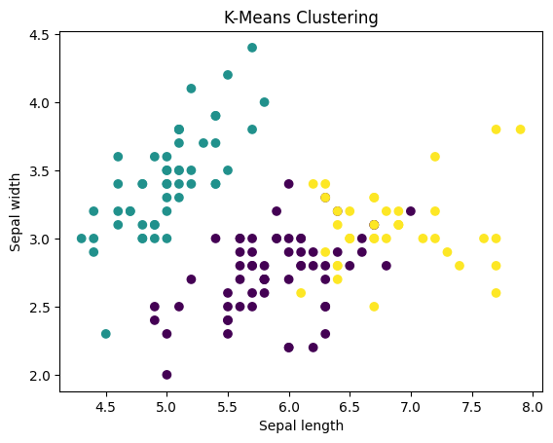

**Hierarchical Clustering**

from sklearn.cluster import AgglomerativeClustering

clustering = AgglomerativeClustering(linkage='ward', affinity='euclidean')

clustering.fit(iris.data)

cluster_labels = clustering.labels_

import scipy.cluster.hierarchy as sch

#single

dendrogram = sch.dendrogram(sch.linkage(iris.data, method='single'))

plt.show()

#average

dendrogram = sch.dendrogram(sch.linkage(iris.data, method='average'))

plt.show()

#complete

dendrogram = sch.dendrogram(sch.linkage(iris.data, method='complete'))

plt.show()

**Elbow optimization**

import pandas as pd

from sklearn.cluster import KMeans

from sklearn.datasets import load_iris

iris = load_iris()

k_range = range(1, 10)

wss_scores = []

for k in k_range:

    kmeans = KMeans(n_clusters=k, random_state=0)

    kmeans.fit(iris.data)

    wss_scores.append(kmeans.inertia_)

import matplotlib.pyplot as plt

plt.plot(k_range, wss_scores, marker="o")

plt.xlabel("Number of clusters")

plt.ylabel("Within-sum-of-squares")

plt.title("Elbow Method")

plt.show()

import pandas as pd

from sklearn.cluster import KMeans

from sklearn.datasets import load_iris

iris = load_iris()

n_clusters = 3

kmeans = KMeans(n_clusters=n_clusters, max_iter=100, random_state=0)

kmeans.fit(iris.data)

cluster_labels = kmeans.predict(iris.data)

import matplotlib.pyplot as plt

plt.scatter(iris.data[:, 0], iris.data[:, 1], c=cluster_labels)

plt.xlabel("Sepal length")

plt.ylabel("Sepal width")

plt.title("K-Means Clustering")

plt.show()

